HILLY FIELDS FOOTBALL CLUB
SEASON 25: 1991-92
FIRST TEAM:
SOUTH LONDON FOOTBALL FEDERATION:
P W D L F A Pts Pos
Division 2 22 8 2 12 56 66 18 7th
Beckenham Hospital Cup 2 1 0 1 9 14
Federation Cup 1 0 0 1 1 3
Junior Challenge Cup 2 1 0 1 5 5
London Junior Cup 1 0 0 1 2 3
Friendly 5 3 1 1 15 7
TOTAL 33 13 3 17 88 98
Apps Gls Apps Gls
Charlie Benson 16 11 Stewart Kain 23 7
Terry Brown 1 0 Kevin McCormick 11 0
Mark Cantwell 1 0 Steve Moreton 6 6
Mark Cooper 1 0 Steve Morton 1 0
Lionel Dore 15 0 Ben Murphy 1 0
Joe Doyle 29 3 Jake Murray 28 1
Jim Flood 4 0 Jamie Murray 10 9
Steve Ford 22 5 Stuart Parsley 23 0
Keith Foster 1 0 Paul Quinn 4 0
Len Franklin 3 0 Mark Rumbelow 23 2
Richard Fryer 1 0 Nick Rumbelow 22 2
Nick Gayle 30 2 Tommy Salacuri 28 29
James Greet 14 3 Charlie Shoppee 30 0
Robert Hare 10 3 Rick Symes 1 0
Lee Harman 18 0 Mario Vaz 1 0
Jeff Harrod 2 0
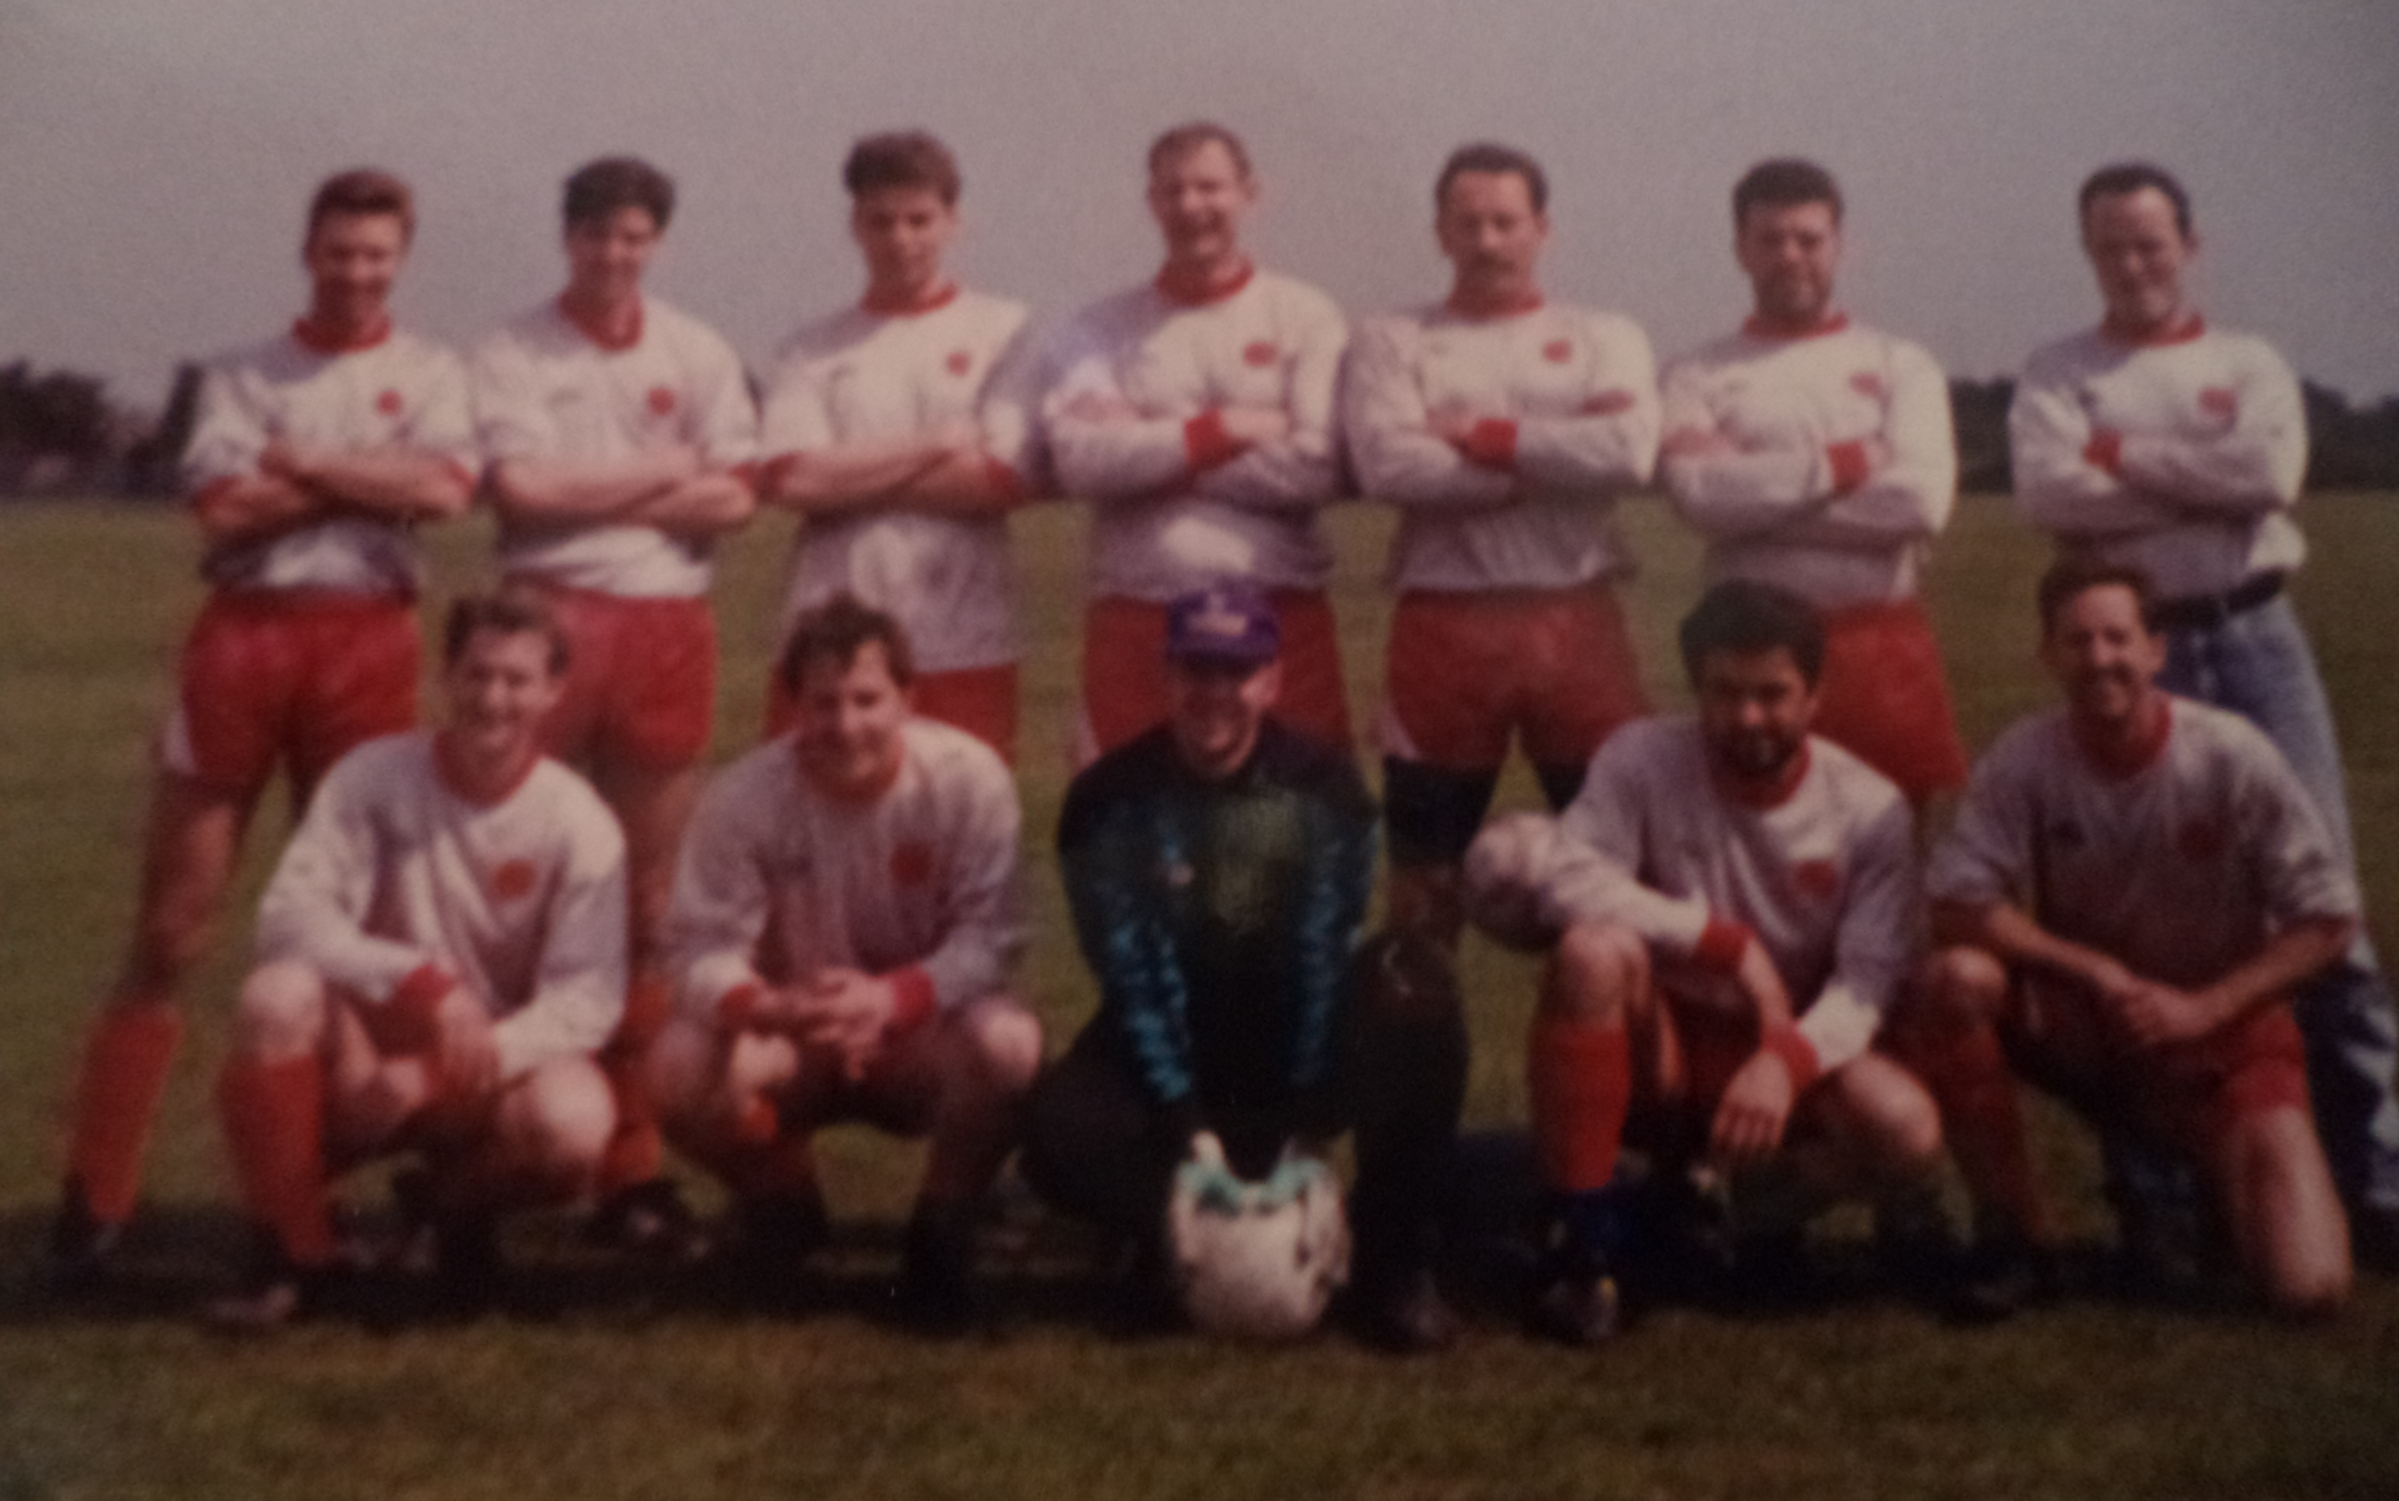
L-R Back: Lionel Dore, Rob Hare, Mark Rumbelow, Keith Foster, Steve Morton, Richard Fryer, Jake Murray L-R Front: Steve Ford, Joe Doyle, Stuart Parsley, Tommy Salacuri, Charlie Shoppee

